*Original Article*

Mucosa-associated gut microbiome in Japanese patients with functional constipation

Yoshihiko Sugitani,1 Ryo Inoue,2 Osamu Inatomi,1 Atsushi Nishida,1 So Morishima,2 Takayuki Imai,1 Masahiro Kawahara,1 Yuji Naito,3 and Akira Andoh1,*

1Department of Medicine, Shiga University of Medical Science, Seta-Tsukinowa, Otsu, Shiga 520-2192, Japan 2Laboratory of Animal Science, Department of Applied Biological Sciences, Faculty of Agriculture, Setsunan University, Nagaotoge-cho 45-1, Hirakata, Osaka 573-0101, Japan

3Department of Molecular Gastroenterology and Hepatology, Kyoto Prefectural University of Medicine, Kyoto 602-8566, Japan

(Received 4 June, 2020; Accepted 14 June, 2020; Published online 30 September, 2020)

The number of patients with chronic constipation is increasing in Japan. We investigated the gut mucosa-associated microbiome in Japanese patients with functional constipation. Diagnosis was made according to the Rome IV criteria. Mucosal samples were obtained by gentle brushing of mucosa surfaces. The gut micro- biome was analyzed using 16S rRNA gene sequencing. There were no significant differences in bacteria α-diversity such as richness and evenness. The PCoA indicated significant structural differences between the constipation group and healthy controls (*p* = 0.017 for unweighted and *p* = 0.027 for weighted). The abundance of the phylum Bacteroidetes was significantly higher in the constipation group. The abundance of the genera *Streptococcus*, *Fusobacterium*, *Comamonas*, and *Alistipes* was significantly higher in the constipation group. The abundance of the genera *Acinetobacter*, *Oscillospilla*, *Mucispirillum*, *Propinibacterium*, and *Anaerotruncus* was significantly lower in the constipation group. In the constipa- tion group, the proportion of genes responsible for sulfur metabo- lism, selenocompound metabolism, sulfur relay system was significantly higher and the proportion of D-arginine and D- ornithine metabolism and flavonoid biosynthesis was significantly lower. In conclusion, we identified differences of the mucosa- associated microbiome between Japanese patients with func- tional constipation and healthy controls. The mucosa-associated microbiome of functional constipation was characterized by higher levels of Bacteroidetes (*Alistipes*).

*Key Words*: microbiota, constipation, butyrate

T

he number of patients with chronic constipation, including constipation-type irritable bowel syndrome (IBS-C) and functional constipation (FC),(1) is increasing in Japan due to lifestyle change and growth of the aging population.(2) A recent report by Kawamura *et al.*(3) showed that the prevalence of IBS-C and FC in a Japanese population was 4.97% and 8.76%, respec- tively. While chronic constipation is rarely fatal, the symptoms associated with constipation restrict patients’ social activities and markedly reduce their quality of life (QOL).(1,4) Chronic constipa- tion is a multifactorial disorder with complex pathophysiology. Previous studies have reported that disturbed gastrointestinal motility, decrease in luminal water content, dysregulated gut-brain axis, alteration of diet, sex hormone fluctuations, and anorectal

dysfunction are etiologic factors.(1,2)

The role of the gut microbiota in human health is recognized as a mutually beneficial interaction between human and micro- organisms that contributes to normal physiology and immune homeostasis.(5) At the same time, alteration of structure and func- tion of the gut microbiota (dysbiosis) is associated with disease, and often characterized by a decreased diversity and proliferation

of pathogenic bacterial taxa.(6) For example, dysbiosis deeply contributes to the pathogenesis of inflammatory bowel disease, which is characterized by mucosal immune dysregulation.(7–9) Some previous studies have described compositional changes in the gut microbiota of patients with IBS-C and FC,(10–12) suggesting an involvement of dysbiosis in the pathophysiology of chronic constipation. Thus, correction of dysbiosis through dietary interventions or fecal microbiota transplantation may represent important strategies to modify the gut microbiota and its metabolite production for health maintenance as well as disease prevention and management.

The gut microbiota consists of two separate populations, the luminal microbiota and the mucosa-associated microbiota (MAM).(13–16) The MAM is considered to directly modulate mucosal function to a greater degree than luminal bacteria and is deeply involved in the pathophysiology of various diseases. However, studies on the gut microbiota of chronic constipation have often used fecal samples because they are easy to collect. Only a few studies have investigated the MAM in patients with chronic constipation using biopsy samples under endoscopy.(10,11) The point to be improved in these studies may be the use of biopsy samples. Endoscopic biopsy is invasive, and a large part of the samples consists of human tissues with extremely small amounts of bacterial components. This may lead to misreading of 16S rRNA sequencing. To overcome this weakness, we have previously reported on the usefulness of endoscopic brush samples for analysis of MAM.(17) Endoscopic brush sampling is non-invasive and makes it possible to avoid massive contamination of human cells.

It has been reported that the gut microbiome of the Japanese is

considerably different from those of the populations of other countries.(18) Most of the studies investigating dysbiosis of chronic constipation have been conducted outside Japan and there are a limited number of studies of the Japanese population. In the present study, we investigated the MAM profile of Japanese patients with functional constipation using endoscopic brush samples.

Materials and Methods

Ethics. This study was approved by the ethics committee of the Shiga University of Medical Science (permission No. 29-135). All patients were managed at the Division of Gastroenterology of the Hospital of the Shiga University of Medical Science. All participants provided written informed consent. The study was

*To whom correspondence should be addressed. E-mail: [andoh@belle.shiga-med.ac.jp](mailto:andoh@belle.shiga-med.ac.jp)

doi: 10.3164/jcbn.20-93

©2021 JCBN

J. Clin. Biochem. Nutr. | March 2021 | vol. 68 | no. 2 | 187–192

registered at the University Hospital Medical Information Network Center (000035733).

Patients and sample collection. We enrolled 15 male patients diagnosed with functional constipation according to the Rome IV criteria(1) and 14 male healthy controls. Healthy controls were age-matched volunteers without any diseases or medications. The average age of the healthy controls and constipation group was 69.0 years (range 49–84) and 71.4 years (37–84), respec- tively. Average Bristol scale score of the healthy controls and constipation group was 4.3 (range 4–5) and 1.9 (range 1–3), respectively. No constipation patients received either antibiotics or probiotics. All participants underwent colonoscopy for screening. A polyethylene glycol-based bowel preparation was performed.

Samples were obtained by gentle brushing of mucosal surfaces avoiding bleeding using cytology brushes (COOK® CCB-7-240-3- S, Bloomington, IN). One sample from the sigmoid colon were obtained from each participant.

DNA extraction. DNA was extracted from samples using QIAamp UCP pathogen mini kit (QIAGEN, Germantown, MD) with Pathogen Lysis Tube S (QIAGEN). Samples were beaten in the presence of zirconia beads using a FastPrep FP100A Instrument (MP Biomedicals, Irvine, CA).(19) The final concentra- tion of the DNA sample was adjusted to 10 ng/ml.

16S rRNA sequencing. The MiSeqTM System (Illumina, San Diego, CA) was used for 16S rRNA sequencing according to a previously described method.(20) Briefly, the V3–V4 hypervariable

regions of 16S rRNA were amplified by polymerase chain reaction (PCR) using the universal primers 341F and 805R, followed by the second PCR to introduce a unique combination of dual indices (I5 and I7 index). The concentrations of the second PCR products was normalized with a SequalPrep Normalization Plate Kit (Life Technologies, Tokyo, Japan) and concentrated using AMPure XP beads (Beckman Coulter, Tokyo, Japan). Ten pM of the library combined with phiX Control was sequenced using a 300-bp paired-end strategy according to the manufac- turer’s instructions.

16S rRNA-based taxonomic analysis. QIIME ver. 1.9,(21)

USEARCH ver. 9.2.64, UCHIME ver. 4.2.40,(22) and VSEARCH

ver. 2.4.3(23) were used for processing of sequence data including chimera check, operational taxonomic unit (OTU) definition and taxonomy assignment. Singletons were omitted. The RDP classifier ver. 2.10.2 with the Greengenes database (published May, 2013)(24) was used for taxonomy assignment of the acquired OTUs.

Statistical analyses. The observed species, Chao1 and Shannon phylogenetic diversity indices were calculated by the R “phyloseq” package(25) and statistically analyzed using the

Bonferroni test. b-Diversity for bacterial microbiome was estimated

using the UniFrac metric. Statistical analysis was performed using permutational multivariate analysis of variance (PERMANOVA). Microbial composition was statistically analyzed by the Kruskal- Wallis test and followed by the unpaired Wilcoxon test using Linear Discriminant Analysis Effect Size (LEfSe)(26) (available at [http://huttenhower.sph.harvard.edu/galaxy/).](http://huttenhower.sph.harvard.edu/galaxy/))

Functional changes in the microbiome. Potential changes

in the microbiome at the functional level were evaluated using PICRUSt software(27) and the Kyoto Encyclopedia of Genes and Genomes (KEGG) database release 70.0.(28) The human-specific pathways were removed from the results to focus on true bacterial pathways. The PICRUSt software uses 16S-rRNA sequence profiles to estimate metagenome content based on reference bacterial genomes and the KEGG pathway database. The results were further analyzed statistically by Welch’s *t* test using the STAMP software.(29) *P* values (<0.05) were used to determine any statistically significant differences between the groups.

Results

We initially compared a-diversity of the MAM between the constipation group and healthy controls. The observed species and the Chao 1 index estimate OTU richness, and the Shannon index represents OTU evenness. As shown in Fig. 1A, there were no significant differences in three indices. These findings indicate that chronic constipation does not affect a-diversity (OTU richness and evenness) of the MAM.

Using the unweighted and weighted UniFrac distance, we compared the overall microbial structure between the constipation group and healthy controls. As shown in Fig. 1B, the unweighted and weighted PCoA indicated significant structural differences between the constipation group and healthy controls (PERMANOVA *p* = 0.017 for unweighted analysis and *p* = 0.027 for weighted analysis).

The differences in the gut microbial structure were taxonomi- cally evaluated at the phylum level (Fig. 2). The abundance of the phylum Bacteroidetes was significantly higher in the constipa- tion group than in healthy controls. There were no significant differences between the two groups in the abundance of other phyla.

Changes in microbial composition of MAM were further analyzed using LEfSe (Fig. 3).(26) The abundance of the class Bateroidia, the genera *Streptococcus*, *Fusobacterium*, *Comamonas*, and *Alistipes* was significantly higher in the constipation group compared to healthy controls (*p*<0.05). On the other hand, the abundance of the genera *Acinetobacter*, *Oscillospilla*, *Mucispirillum*, *Propinibacterium*, and *Anaerotruncus* was signifi- cantly lower in the constipation group.

Potential differences in the function of the microbiome were evaluated using PICRUSt software (Fig. 4).(27) When comparing the constipation group with healthy controls, the proportion of genes responsible for sulfur metabolism, selenocompound metabolism, sulfur relay system was significantly higher in the constipation group. The proportion of genes responsible for D- arginine and D-ornithine metabolism, vitamin B6 metabolism, flavonoid biosynthesis was significantly lower in the constipation group.

Discussion

Investigation of specific gut microbiome associated with chronic constipation may be important for diagnostic and thera- peutic purposes. However, there are a limited number of reports concerning the gut microbiome of chronic constipation using 16 rRNA sequencing.(30) Furthermore, most studies have used fecal samples which are readily accessible but do not represent mucosa- associated profiles. This is a crucial limitation because the MAM might directly stimulate mucosal function to a greater degree than the fecal microbiome. As far as we could ascertain, a recent article by Parthasarathy *et al.*(10) is the sole report of the MAM of patients with chronic constipation using 16 rRNA sequencing. Further- more, the gut microbiome of the Japanese has been reported to be considerably different from that of the populations in other countries.(18) It is therefore worthwhile investigating the MAM of Japanese patients with chronic constipation. This is the first report of the MAM of FC in a Japanese population using 16S rRNA sequencing.

We used mucus samples obtained by gentle brushing of

mucosal surfaces under colonoscopy. In the previous studies, sam- ples for MAM analysis were obtained by mucosal biopsy.(10,14,31,32) Mucosal biopsy is invasive and sometimes causes unexpected bleeding, and the major part of the biopsy sample is human tissue (or cells) but contains minimal bacterial components. Endoscopic brush sampling is safe and effectively avoids massive contamina- tion of human cells. This may be ideal for metagenomics, since removal of human genome data is essential for the analysis of

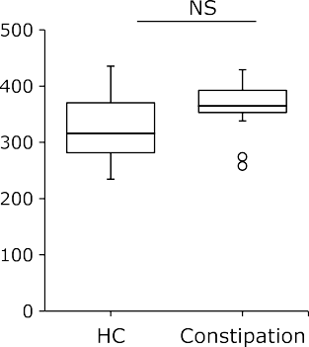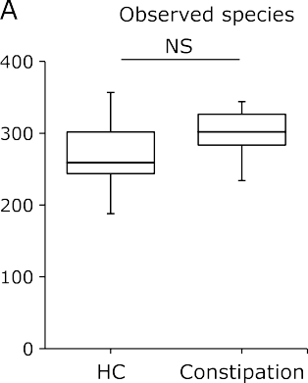



Fig. 1. Comparative analyses for the microbial community of functional constipation and healthy controls. (A) *a*-Diversity indices of the constipa- tion group (*n* = 15) and healthy controls (HC; *n* = 14). \**p*<0.05 by Bonferroni test. (B) Unweighted and weighted PCoA of *b*-diversity measures. In both analyses, the microbial community was significantly different between the constipation group and HC. See color figure in the on-line version.

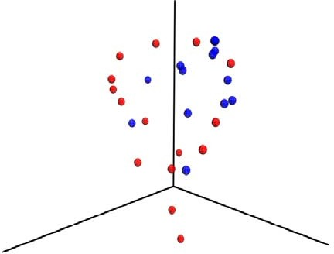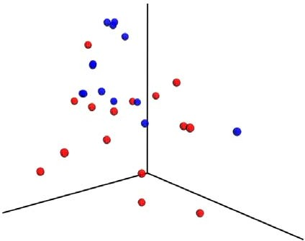



# 

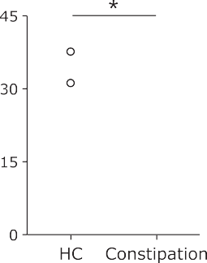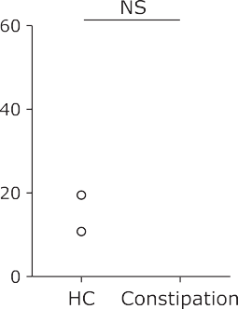



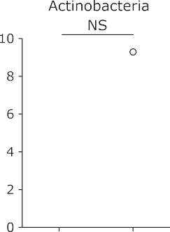

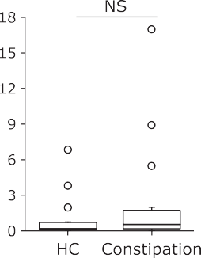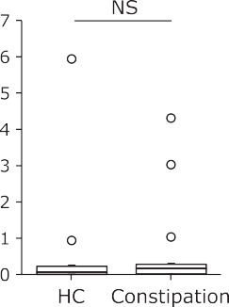Fig. 2. Comparative analyses of the taxonomic composition of the microbial community at the phylum level. HC, healthy controls. \**p*<0.05 by Bonferroni test.





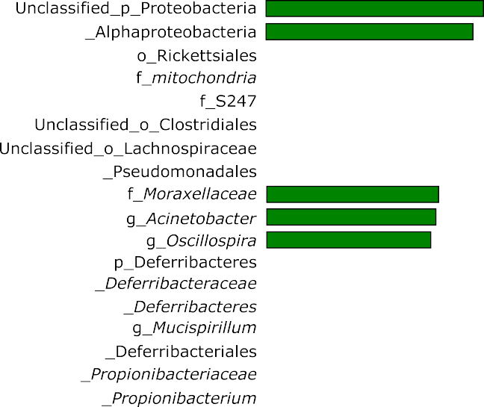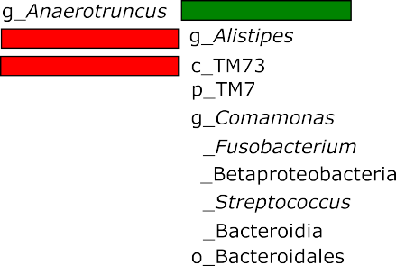





Fig. 3. Alteration of the relative abundance of bacteria in the gut mucosa-associated microbiome of functional constipation analyzed by the linear discriminant analysis effect size (LEfSe). The histogram indicates the Linear Discriminant Analysis (LDA) score. These taxa showed a statistically significant difference between the constipation group and healthy controls (HC) (*p*<0.05 by the Kruskal-Wallis test).

the microbiome.

In this study, there were no significant differences in OTU- richness and OTU-evenness between the constipation group and healthy controls, indicating that stool retention does not affect mucosal bacterial growth or diversity. Our observations oppose to a previous report of fecal samples of pediatric patients,(33) in which an increase in OTU richness has been described. So, in order to clarify this point, further studies should be performed in the future. A phylogenetic PCoA showed significant differences in the ecological diversities of the gut microbiome between the constipa- tion group and healthy controls, indicating a strong association of constipation with the structure or composition of MAM.

The current study showed that the microbiome of chronic constipation was characterized by a greater abundance of the phylum Bacteroidetes. The genera *Alistipes*, *Streptococcus*, *Fusobacterium*, *Comamonas*, and *Alistipes* were also higher in the constipation group. On the other hand, lower levels of the genera *Acinetobacter*, *Oscillospilla*, *Mucispirillum*, *Propinibacterium*,

and *Anaerotruncus* were observed in the constipation group.

Concerning the abundance of the phylum Bacteroidetes in constipated patients, previous studies have reported conflicting results. Parthasarathy *et al.*(10) describe an increase in the phylum Bacteroidetes in the MAM, while Zhu *et al.*(33) demonstrated a decrease in Bacteroidetes in fecal samples. Our finding from the MAM is in agreement with the result of Parthasarathy *et al.*(10) It may be that the difference of sample sources, mucosa or feces, affected these observations. We observed the higher level of the genus *Alistipes*. *Alistipes* is one of the abundant members of the gut microbiome in healthy people,(34,35) and most *Alistipes* are indole-positive and capable of metabolizing tryptophan. Tryptophan is converted to 5-hydroxytryptophan, which is then converted to serotonin.(36) Serotonin stimulates gut motility. In contrast, the second tryptophan metabolism pathway is the kynurenine pathway.(36) This is the dominant pathway and kynurenine is produced from tryptophan by tryptophan-2,3-dioxygenase (TDO) or indolamine-2,3-dioxygenase (IDO). Kynurenine synthesis reduces the tryptophan available for serotonin synthesis.(36) Reduced 5-hydroxytryptophan levels have been demonstrated in some patients with slow transit constipation.(1) So, association of a greater abundance of *Alistipes* and tryptophan metabolism such as kynurenine pathway should be investigated as a candidate of one of factors contributing to the pathophysiology of chronic constipation.

We identified that the proportion of genes responsible for sulfur

metabolism and sulfur relay system was higher in the MAM of the constipation group. Dietary amino acids, such as cysteine and methionine, are a source of sulfated compounds in the colon,(37) and hydrogen sulfide is major sulfur derivative. Whether role of hydrogen sulfide in the colon is detrimental or beneficial remains a matter of debate.(37) Several lines of evidence have indicated that hydrogen sulfide is a potential player in the etiology of intestinal disorders such as inflammatory bowel diseases and colorectal cancer,(37) but the significance of sulfur metabolism in the patho- physiology of chronic constipation remains unclear. Further characterization of the microbial pathways involved in colonic sulfur metabolism is necessary for a clearer understanding of its contribution to chronic constipation.

In conclusion, we identified differences in the mucosa-

associated microbiome between Japanese patients with functional constipation and healthy controls. The MAM of functional constipation was characterized by the greater abundance of *Bacteridetes* (*Alistipes*). These may affect epithelial and mucosal functions and induce constipation. Based on the findings of this study, a novel therapeutic strategy which is more suitable for the Japanese should be designed in the future.

Author Contributions

RI, MK, OI, YN and AA conceived the project, designed and supervised the experiments, interpreted results, and wrote the paper with input from all other authors. YS and TI performed experiments and data analysis.

Acknowledgments

This study was supported in part by a Grant-in-Aid for Scientific Research from the Ministry of Education, Culture, Sports, Science and Technology of Japan (18K08002), a grant for the Intractable Diseases from the Ministry of Health, Labor and Welfare of Japan.

Conflict of Interest

No potential conflicts of interest were disclosed.

# 

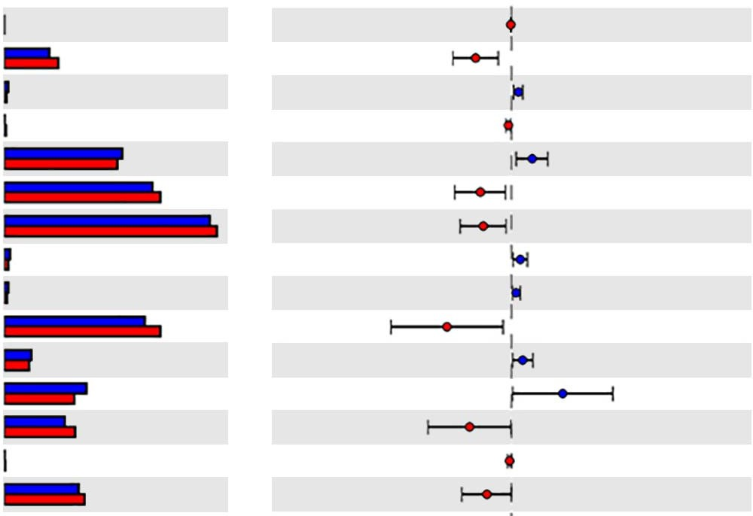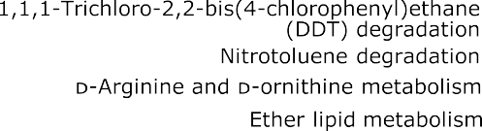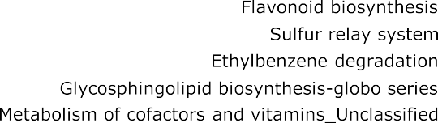

 

Fig. 4. PICRUSt predictions of the functional composition of metagenome using 16S rRNA gene data and a data base of reference genomes.(27) The KEGG database(28) functional categories are shown with the displayed histograms and *p* value determinations, as calculated by the STAMP software.(29)

References

1. Mearin F, Lacy BE, Chang L, *et al*. Bowel disorders. *Gastroenterology* 2016;

150: 1393–1407.

1. Vazquez Roque M, Bouras EP. Epidemiology and management of chronic constipation in elderly patients. *Clin Interv Aging* 2015; 10: 919–930.
2. Kawamura Y, Yamamoto S, Funaki Y, *et al*. Internet survey on the actual situation of constipation in the Japanese population under 70 years old: focus on functional constipation and constipation-predominant irritable bowel syndrome. *J Gastroenterol* 2020; 55: 27–38.
3. Kosako M, Akiho H, Miwa H, Kanazawa M, Fukudo S. Impact of symptoms by gender and age in Japanese subjects with irritable bowel syndrome with constipation (IBS-C): a large population-based internet survey. *Biopsychosoc Med* 2018; 12: 12.
4. Rautava S, Luoto R, Salminen S, Isolauri E. Microbial contact during pregnancy, intestinal colonization and human disease. *Nat Rev Gastroenterol Hepatol* 2012; 9: 565–576.
5. Goldsmith JR, Sartor RB. The role of diet on intestinal microbiota metabolism: downstream impacts on host immune function and health, and therapeutic implications. *J Gastroenterol* 2014; 49: 785–798.
6. Sheehan D, Moran C, Shanahan F. The microbiota in inflammatory bowel disease. *J Gastroenterol* 2015; 50: 495–507.
7. Kostic AD, Xavier RJ, Gevers D. The microbiome in inflammatory bowel disease: current status and the future ahead. *Gastroenterology* 2014; 146: 1489–1499.

9 Li J, Butcher J, Mack D, Stintzi A. Functional impacts of the intestinal microbiome in the pathogenesis of inflammatory bowel disease. *Inflamm Bowel Dis* 2015; 21: 139–153.

1. Parthasarathy G, Chen J, Chen X, *et al*. Relationship between microbiota of the colonic mucosa vs feces and symptoms, colonic transit, and methane production in female patients with chronic constipation. *Gastroenterology* 2016; 150: 367–379.e1.
2. Sundin J, Aziz I, Nordlander S, *et al*. Evidence of altered mucosa-associated and fecal microbiota composition in patients with irritable bowel syndrome. *Sci Rep* 2020; 10: 593.
3. Vandeputte D, Falony G, Vieira-Silva S, Tito RY, Joossens M, Raes J. Stool consistency is strongly associated with gut microbiota richness and composition, enterotypes and bacterial growth rates. *Gut* 2016; 65: 57–62.
4. Ringel Y, Maharshak N, Ringel-Kulka T, Wolber EA, Sartor RB, Carroll

IM. High throughput sequencing reveals distinct microbial populations within the mucosal and luminal niches in healthy individuals. *Gut Microbes* 2015; 6: 173–181.

1. Sartor RB. Gut microbiota: optimal sampling of the intestinal microbiota for research. *Nat Rev Gastroenterol Hepatol* 2015; 12: 253–254.
2. Kashiwagi S, Naito Y, Inoue R, *et al*. Mucosa-associated microbiota in the gastrointestinal tract of healthy Japanese subjects. *Digestion* 2020; 101: 107– 120.
3. Fukui A, Takagi T, Naito Y, *et al*. Higher levels of streptococcus in upper gastrointestinal mucosa associated with symptoms in patients with functional dyspepsia. *Digestion* 2020; 101: 38–45.
4. Nishino K, Nishida A, Inoue R, *et al*. Analysis of endoscopic brush samples identified mucosa-associated dysbiosis in inflammatory bowel disease. *J Gastroenterol* 2018; 53: 95–106.
5. Nishijima S, Suda W, Oshima K, *et al*. The gut microbiome of healthy Japanese and its microbial and functional uniqueness. *DNA Res* 2016; 23: 125–133.

19 Kawada Y, Naito Y, Andoh A, Ozeki M, Inoue R. Effect of storage and DNA extraction method on 16S rRNA-profiled fecal microbiota in Japanese adults. *J Clin Biochem Nutr* 2019; 64: 106–111.

1. Inoue R, Sakaue Y, Sawai C, *et al*. A preliminary investigation on the relationship between gut microbiota and gene expressions in peripheral mononuclear cells of infants with autism spectrum disorders. *Biosci Biotechnol Biochem* 2016; 80: 2450–2458.
2. Caporaso JG, Kuczynski J, Stombaugh J, *et al*. QIIME allows analysis of high-throughput community sequencing data. *Nat Methods* 2010; 7: 335–336.
3. Edgar RC. Search and clustering orders of magnitude faster than BLAST.

*Bioinformatics* 2010; 26: 2460–2461.

1. Rognes T, Flouri T, Nichols B, Quince C, Mahé F. VSEARCH: a versatile open source tool for metagenomics. *PeerJ* 2016; 4: e2584.
2. DeSantis TZ, Hugenholtz P, Larsen N, *et al*. Greengenes, a chimera-checked 16S rRNA gene database and workbench compatible with ARB. *Appl Environ Microbiol* 2006; 72: 5069–5072.
3. McMurdie PJ, Holmes S. phyloseq: an R package for reproducible interac- tive analysis and graphics of microbiome census data. *PLoS One* 2013; 8: e61217.
4. Segata N, Izard J, Waldron L, *et al*. Metagenomic biomarker discovery and explanation. *Genome Biol* 2011; 12: R60.
5. Langille MG, Zaneveld J, Caporaso JG, *et al*. Predictive functional profiling

of microbial communities using 16S rRNA marker gene sequences. *Nat Biotechnol* 2013; 31: 814–821.

1. Kanehisa M, Goto S, Sato Y, Kawashima M, Furumichi M, Tanabe M. Data, information, knowledge and principle: back to metabolism in KEGG. *Nucleic Acids Res* 2014; 42: D199–D205.

29 Parks DH, Tyson GW, Hugenholtz P, Beiko RG. STAMP: statistical analysis of taxonomic and functional profiles. *Bioinformatics* 2014; 30: 3123–3124.

1. Ohkusa T, Koido S, Nishikawa Y, Sato N. Gut microbiota and chronic constipation: a review and update. *Front Med (Lausanne)* 2019; 6: 19.
2. Forbes JD, Van Domselaar G, Bernstein CN. Microbiome survey of the inflamed and noninflamed gut at different compartments within the gastro- intestinal tract of inflammatory bowel disease patients. *Inflamm Bowel Dis* 2016; 22: 817–825.

phenotypic identifications of *Bacteroides putredinis* to *Alistipes* species using molecular methods. *Anaerobe* 2011; 17: 130–134.

1. Nagai F, Morotomi M, Watanabe Y, Sakon H, Tanaka R. *Alistipes indistinctus* sp. nov. and *Odoribacter laneus* sp. nov., common members of the human intestinal microbiota isolated from faeces. *Int J Syst Evol Microbiol* 2010; 60 (Pt 6): 1296–1302.
2. O'Mahony SM, Clarke G, Borre YE, Dinan TG, Cryan JF. Serotonin, tryptophan metabolism and the brain-gut-microbiome axis. *Behav Brain Res* 2015; 277: 32–48.
3. Carbonero F, Benefiel AC, Gaskins HR. Contributions of the microbial hydrogen economy to colonic homeostasis. *Nat Rev Gastroenterol Hepatol* 2012; 9: 504–518.
4. Parkes GC, Rayment NB, Hudspith BN, *et al*. Distinct microbial populations

exist in the mucosa-associated microbiota of sub-groups of irritable bowel syndrome. *Neurogastroenterol Motil* 2012; 24: 31–39.

1. Zhu L, Liu W, Alkhouri R, *et al*. Structural changes in the gut microbiome of constipated patients. *Physiol Genomics* 2014; 46: 679–686.
2. Tyrrell KL, Warren YA, Citron DM, Goldstein EJC. Re-assessment of

This is an open access article distributed under the terms of the Creative Commons Attribution-NonCommercial-NoDerivatives License ([http://creativecommons.org/licenses/by-nc-nd/4.0/).](http://creativecommons.org/licenses/by-nc-nd/4.0/))